T2M Panel: “Dialectic of Speed, Slowness, and Waiting,” Sept. 19, 2014
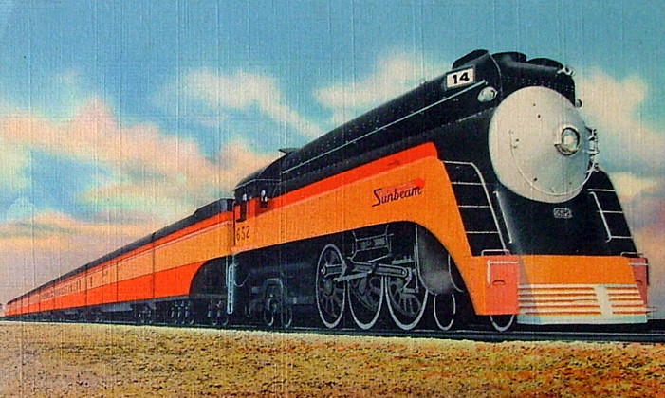

THE HISTORICAL RELATIVISM OF HIGH SPEED ON PASSENGER RAILWAYS: 1830-PRESENT
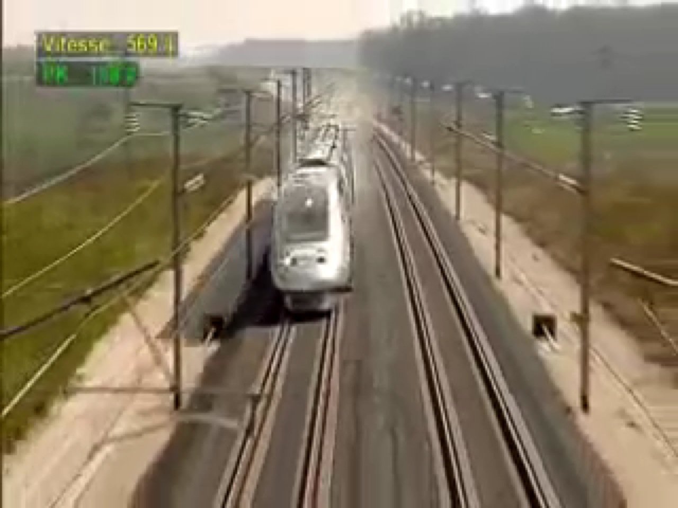
Jim Cohen, Ph.D., Professor Emeritus
Director, Research Initiatives
Institute for Transportation Systems
The City University of New York
Slide 2
jcohen@jjay.cuny.edu
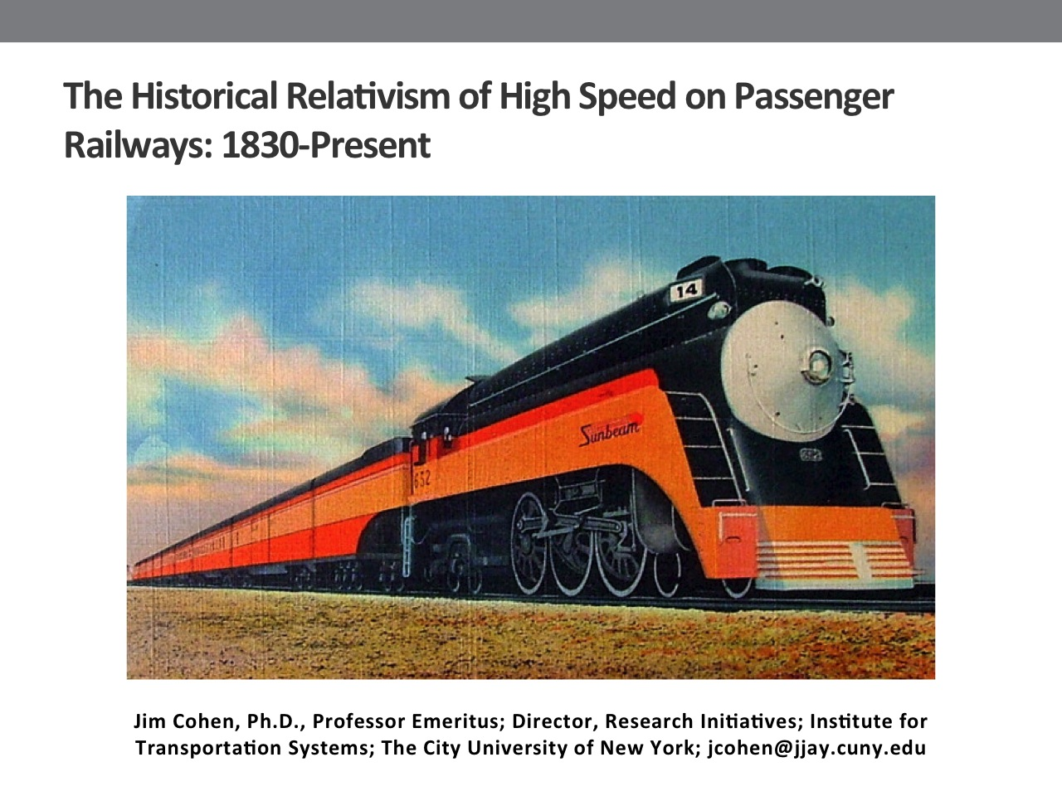
(SLIDE 1: PAPER TITLE PAGE)
Slide 1

(SLIDE 2: VIDEO)

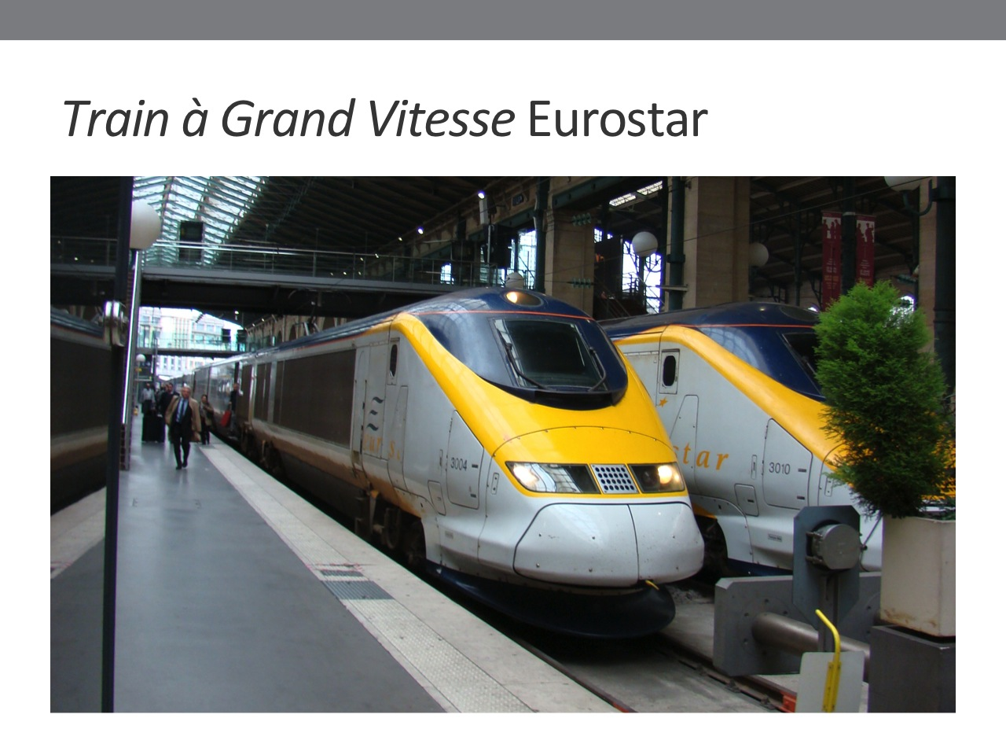
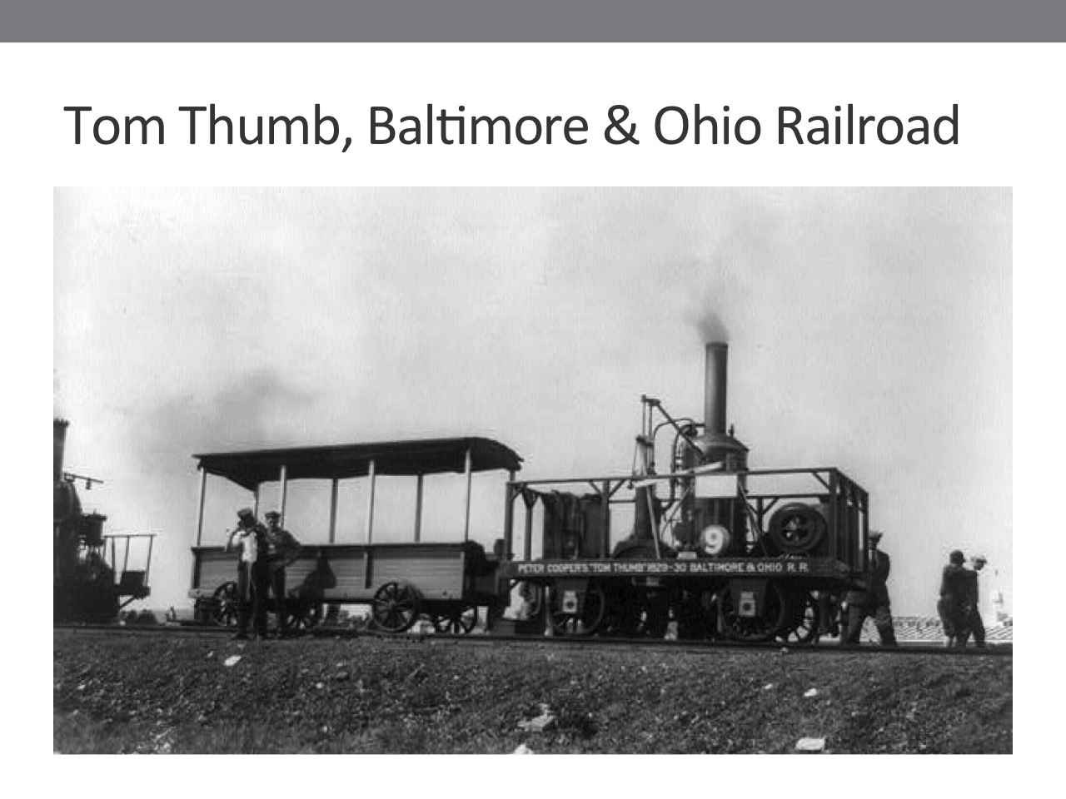
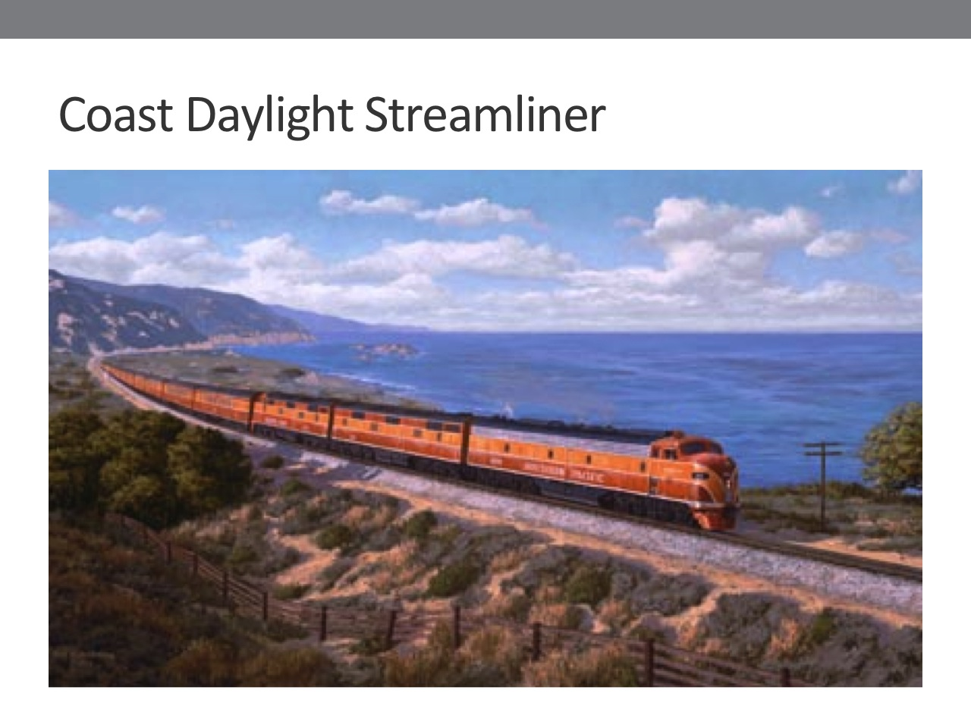
About 3 years ago, I started thinking about high speed trains, which led me to the following question: at what point in history can we say that trains became “high speed”? Is it only in the current era, after Japan introduced its Bullet Train, and France its Train à Grand Vitesse (TGV), (SLIDE 3: EUROSTAR)? What about the American trains called streamliners, (SLIDE 4: COAST DAYLIGHT STREAMLINER) which were the ultimate in modernity and speed in the 1930’s, 40’s and 50’s? Or could one even say that the very first passenger trains, in the 1830’s and 40’s (SLIDE 5: TOM THUMB, B&O RR), which were 100-200 percent faster than horse-drawn stagecoaches, were high speed?
Slide 3
Slide 4
Slide 5

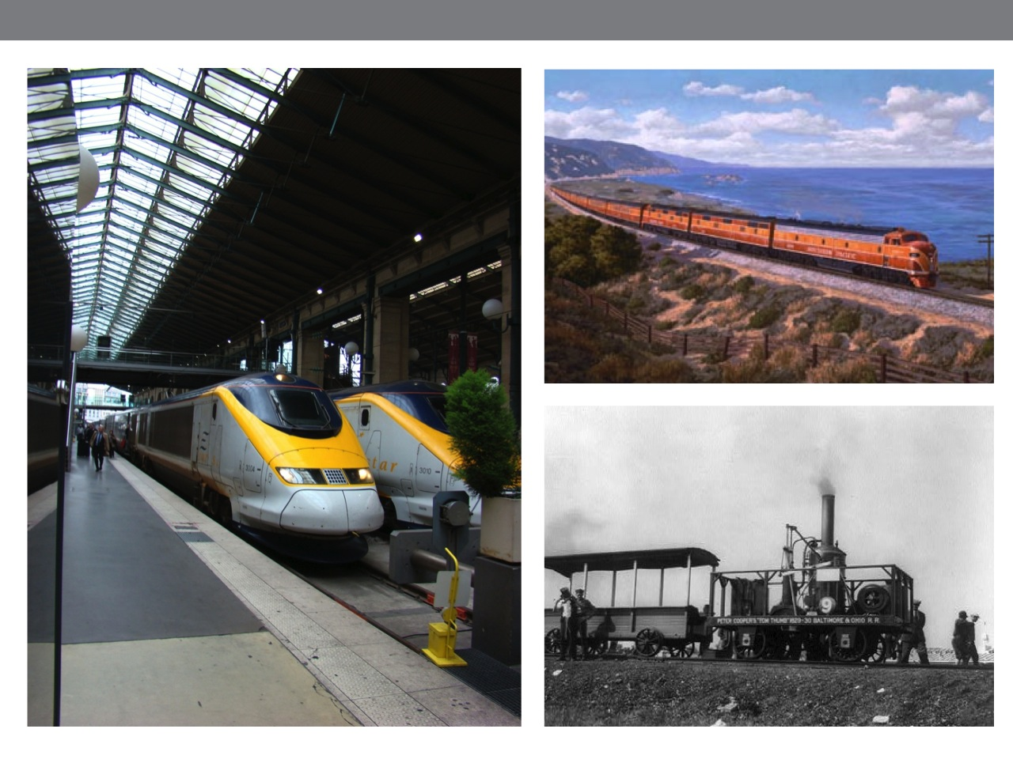
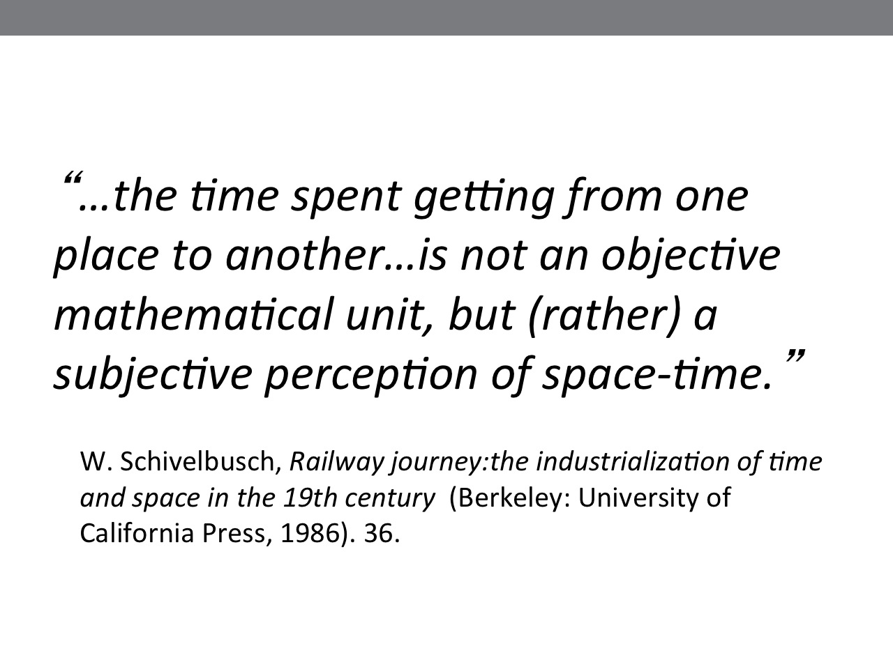
Slide 6
Slide 7
I make 2 arguments in this paper: first, that all of these were high speed trains (SLIDE 6: 3 TRAINS ON ONE SLIDE) because high speed is not an absolute rate of movement. It is historically contingent or relative, defined partly in relation to previous rates of movement, partly by mass media, and partly--as Schivelbusch pointed out--through subjective perception. (SLIDE 7: SCHIVELBUSCH QUOTE)
1. Read quote.
Second, high speed is a necessary condition for profitable operations in passenger rail. But, since, as I and my colleagues on this panel propose, speed is intrinsically dialectical—fastness and slowness always co-exist—then maybe slowness can also lead to profitable operations.
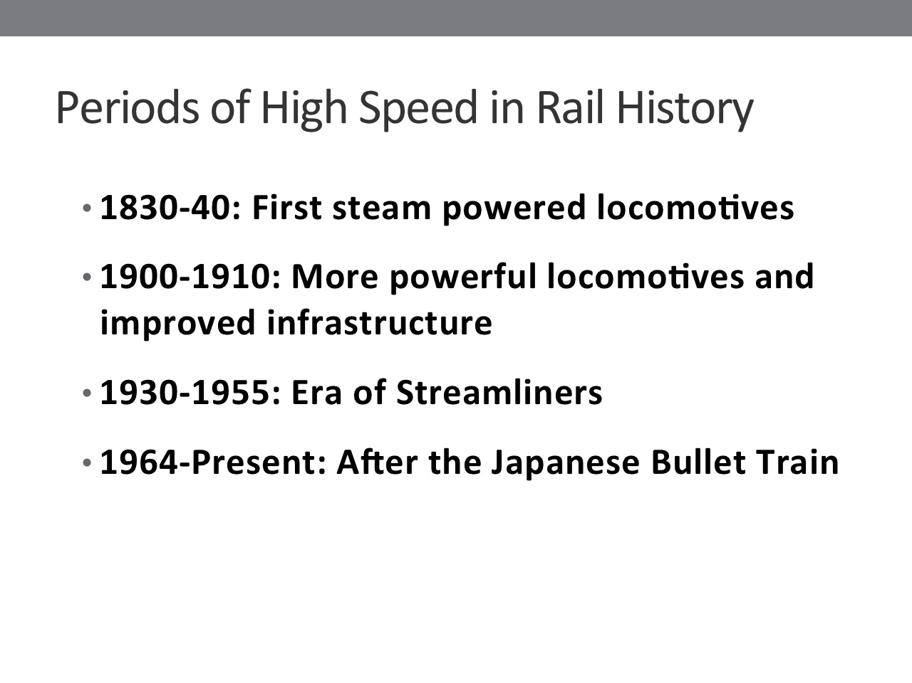
(SLIDE 8: OUTLINE OF PRESENTATION)
1. These are the subjects that I will discuss today first, 4 historic periods of railway high speed.
2. The social construction of high speed.
3. High speed and rail finances.
4. Policy implications of my argument.

PERIODS OF HIGH SPEED IN RAIL HISTORY
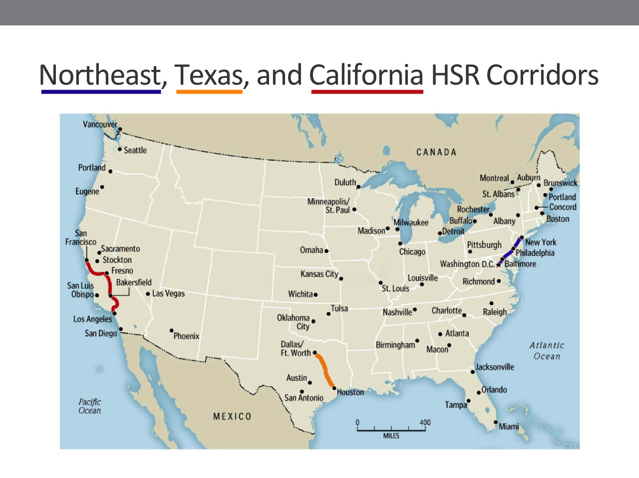
First, I turn to the 4 historic periods of high speed in the United States (SLIDE 9: FOUR HISTORIC PERIODS OF HIGH SPEED): 1830-40; 1900-1910; 1930-1955; and 1964 to the present. I examine these periods on 3 intercity corridors where high speed trains have a long history in this country. (SLIDE 10: MAP OF 3 CORRIDORS)

** Point out/identify the 3 corridors.
Slide 10
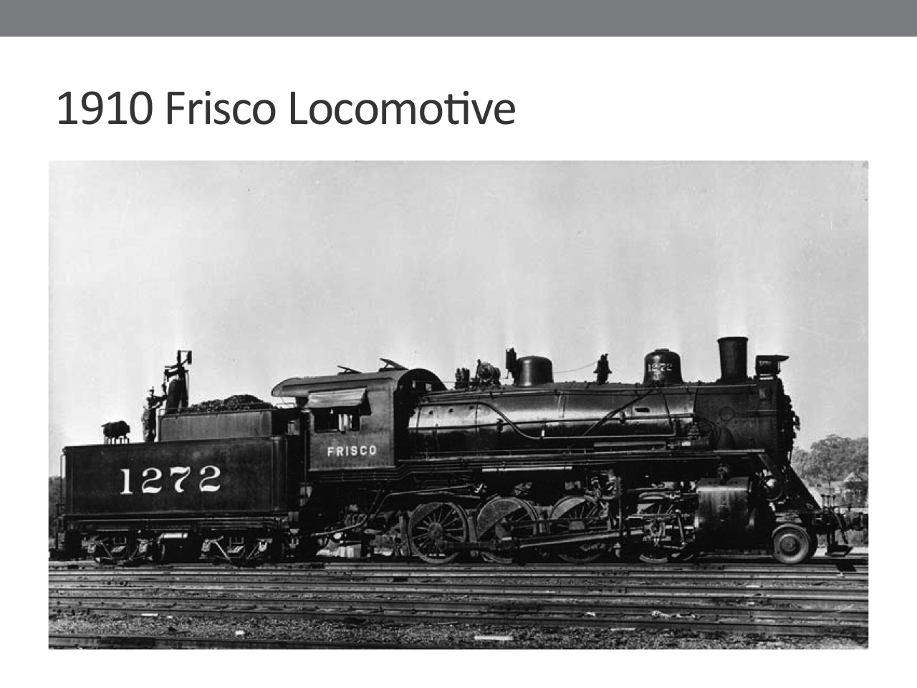
The earliest period of high speed occurs after steam locomotives began pulling passenger trains, in the 1830’s. For example, Peter Cooper’s locomotive, the Tom Thumb pulled passenger trains SLIDE 11: TOM THUMB LOCOMOTIVE) at a top speed of 29 miles per hour (mph), on the Baltimore and Ohio Railroad. Average speed was lower, probably in the range of 15-20 mph, due to starting and stopping along the route. The speed of these earliest trains was 100-200% higher than that of horse-drawn stagecoaches, which ran at top speeds of only 7-10 mph. The Tom Thumb was truly a high speed train.
Slide 11

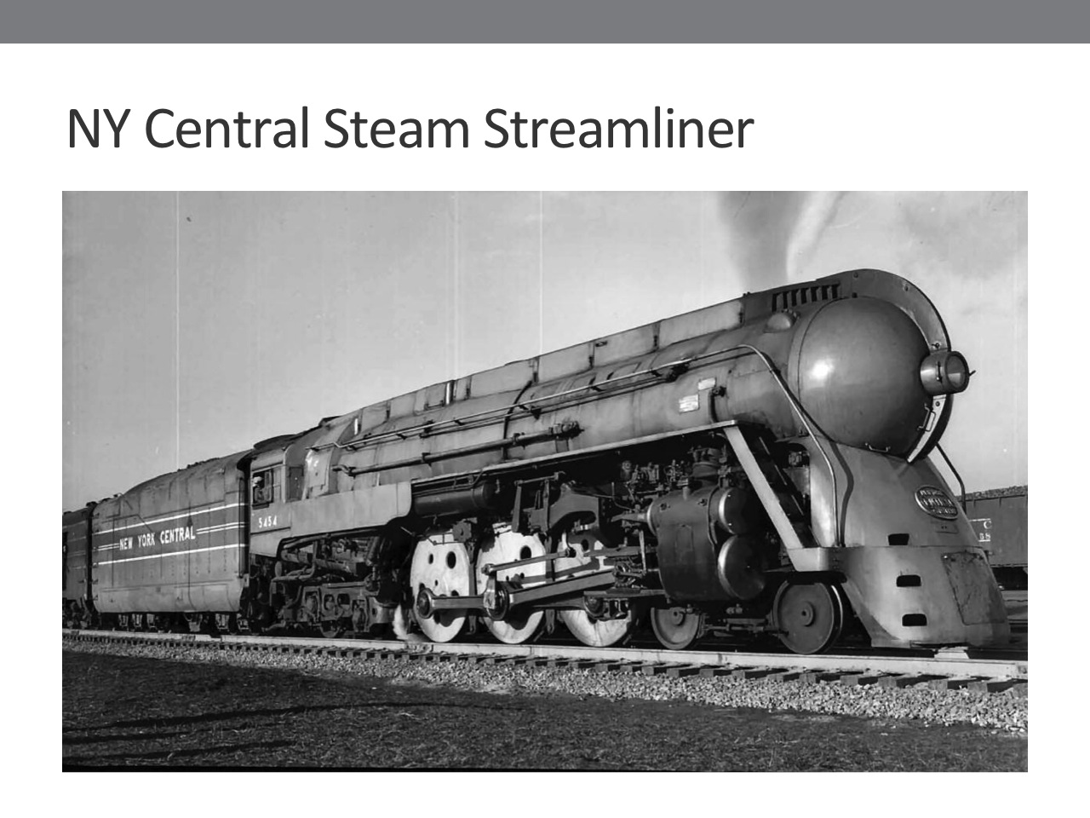
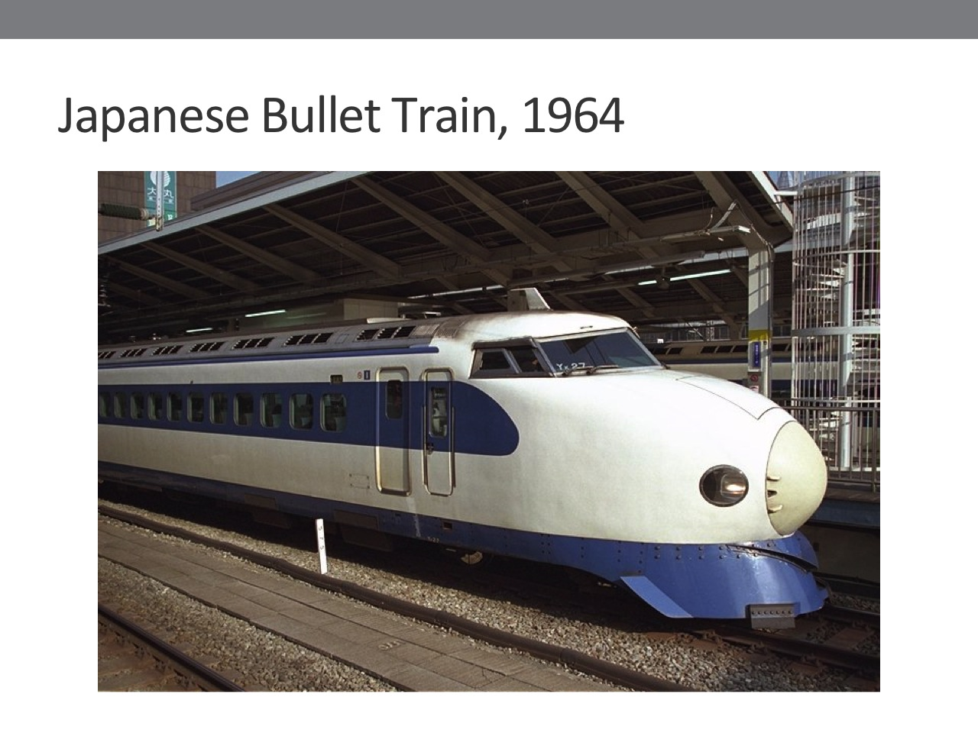
The second period of high speed occurs at the turn of the 20th century, after the introduction of more powerful locomotives and improved infrastructure on all 3 corridors. (SLIDE 12: 1910 FRISCO LOCOMOTIVE)

Slide 13
Slide 14
1. Mfg’d by ALCO (American Locomotive Corporation)
2. Coal powered, steam locomotive. 42,000 lbs tractive effort.
3. 2-8-0 wheel configuration = most common in this era.
4. 64’ long, 185,000 lbs.
Then, in the 1930’s, the introduction of streamliners, built of lightweight stainless steel, created another leap to high speed. (SLIDE 13: NY CENTRAL STEAM STREAMLINER)
1. Mfg’d by ALCO.
2. Coal powered, steam loco. 47,600 lbs tractive effort. (Later, by 1950’s, most locomotives on streamliners were diesel-electric.)
3. Held world speed record in 1936: 124.5 mph.
The most recent era started in the 1960’s, after Japan had inaugurated its Bullet Train. (SLIDE 14: JAPANESE BULLET TRAIN)
1. All electric power.
2. Constructed using light weight materials, so faster than earlier locomotives.
3. 150 mph in 1964.
I have compiled speed data from RR timetables for a 90 year period, 1890-1980, and placed this data into column charts. These charts graphically show the 3 historic periods of high speed on each rail corridor. (SHOW SLIDES 15-18: CHARTS)
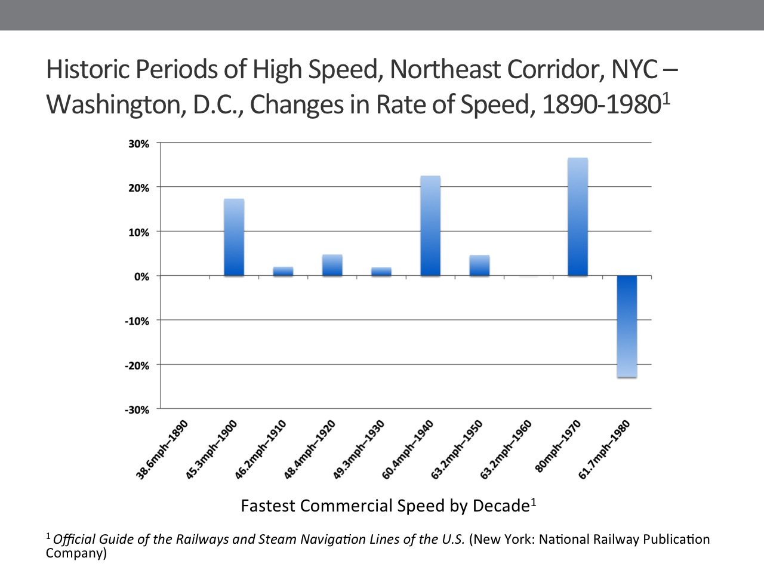
1. X Axis: Timetable data: fastest trip between city pairs at end of each decade.
Slide 15
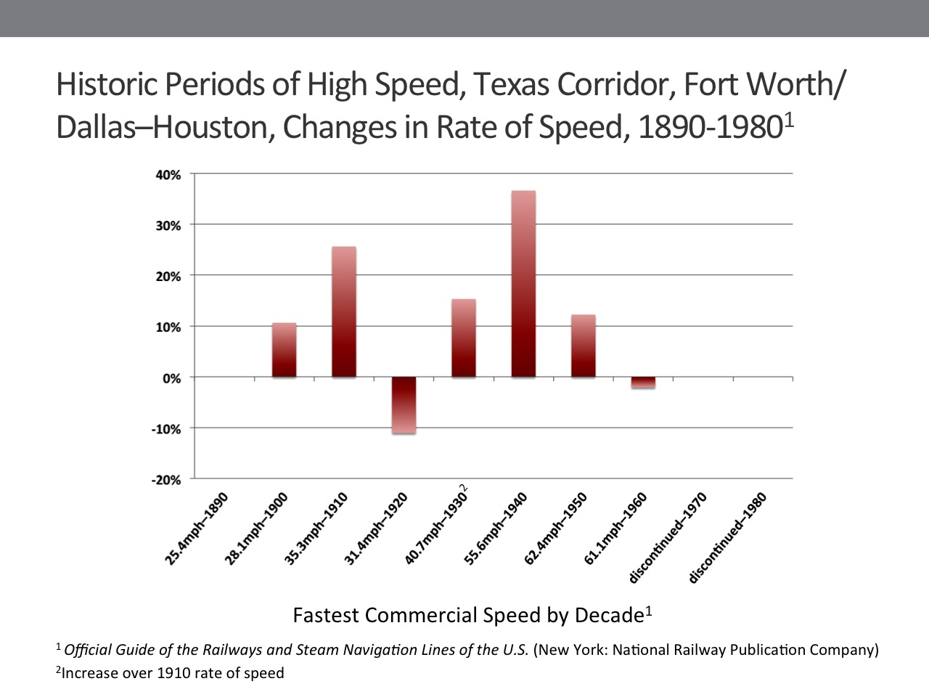
2. Y Axis: % change in speed = periods of high speed.
3. NEC: 3 periods.
4. Texas: 2 periods. Passenger trains discontinued in 1967.
Slide 16
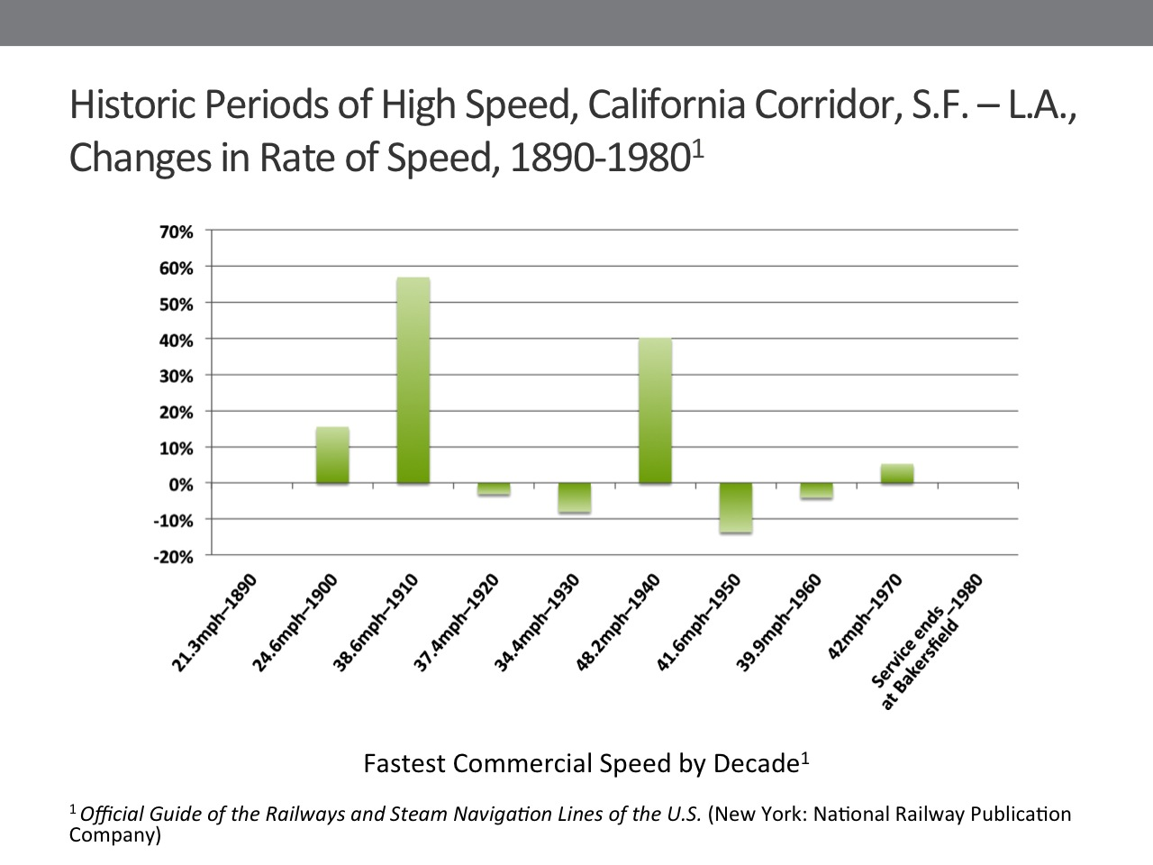
5. California: 2 periods. Thru serviced to L.A. discontinued in late 1970’s. Trains now stop at Bakersfield; transfer to bus.

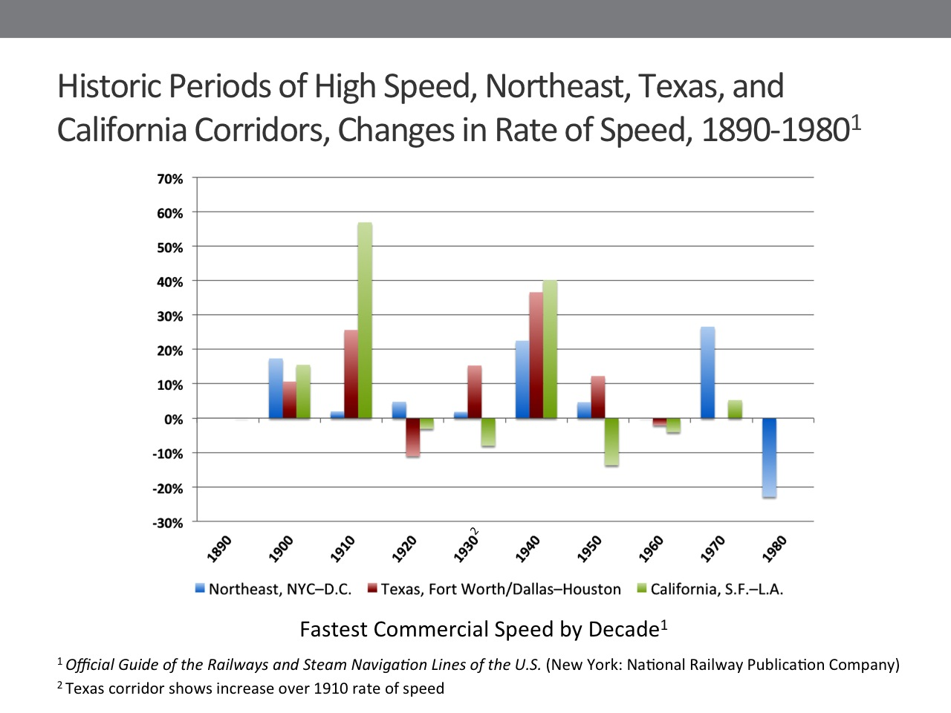
Slide 17
Slide 18
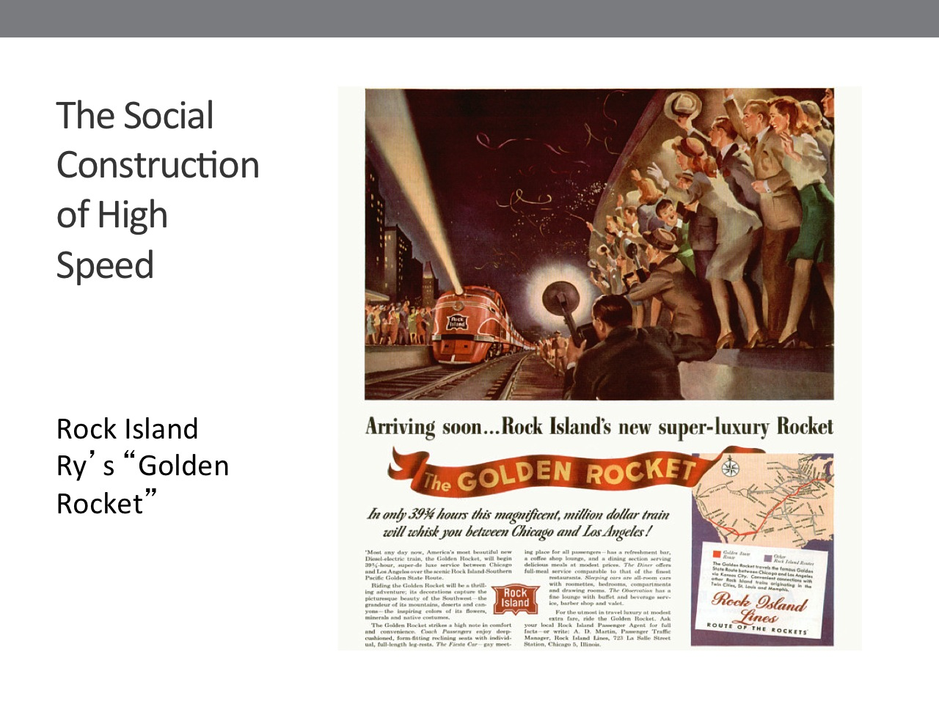
SOCIAL CONSTRUCTION OF HIGH SPEED (SLIDE 19: ROCK ISLAND RY’S GOLDEN ROCKET)

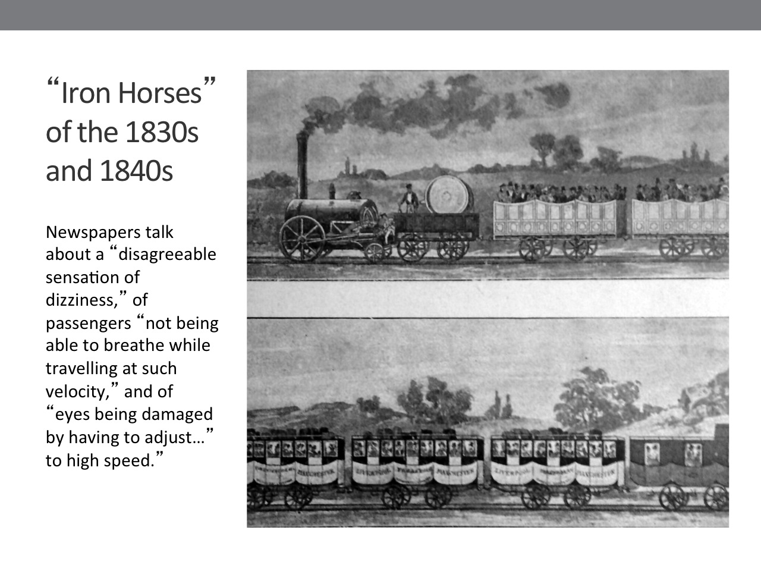
In each of the historic eras, rail companies and mass media promoted and advertised trains as being uniquely fast/high speed. This social construction was absorbed into the collective consciousness of the nation.
Slide 19
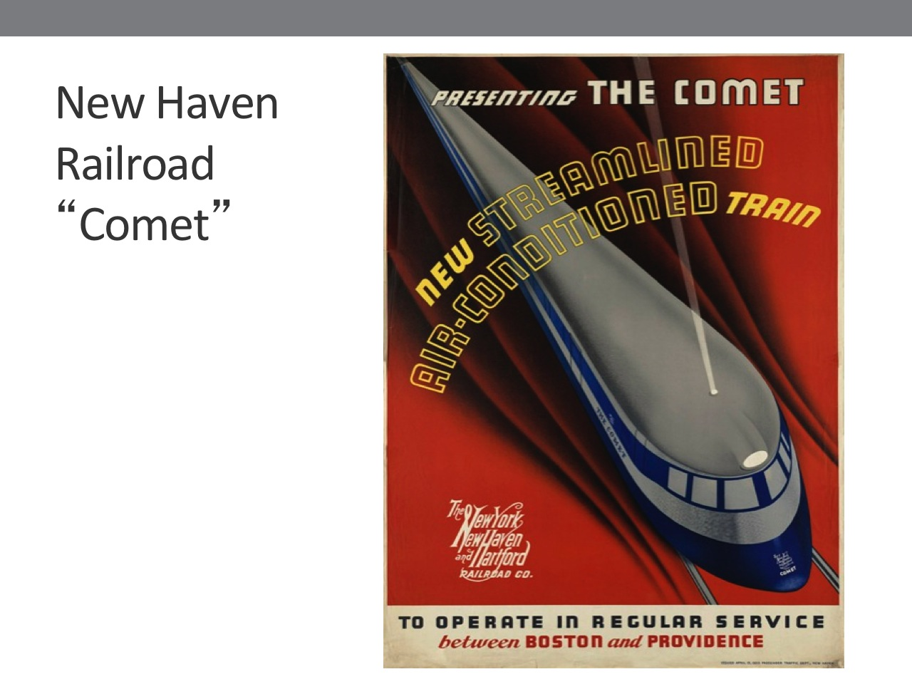
For example, in the 1830’s and 40’s, local newspapers and journals glorified the amazing technological leap forward brought about by steam locomotives. They also reported that trains produced a “disagreeable sensation of dizziness,” (SLIDE 20: LIVERPOOL-MANCHESTER RAILWAY) of passengers “not being able to breathe while travelling at (high) velocity,” and of “eyes being damaged by having to adjust…” to high speed. But, within both the glorification and fear was the idea that these “iron horses” involved high speed, and this idea was absorbed into collective consciousness of the nation.
Slide 20
Slide 21
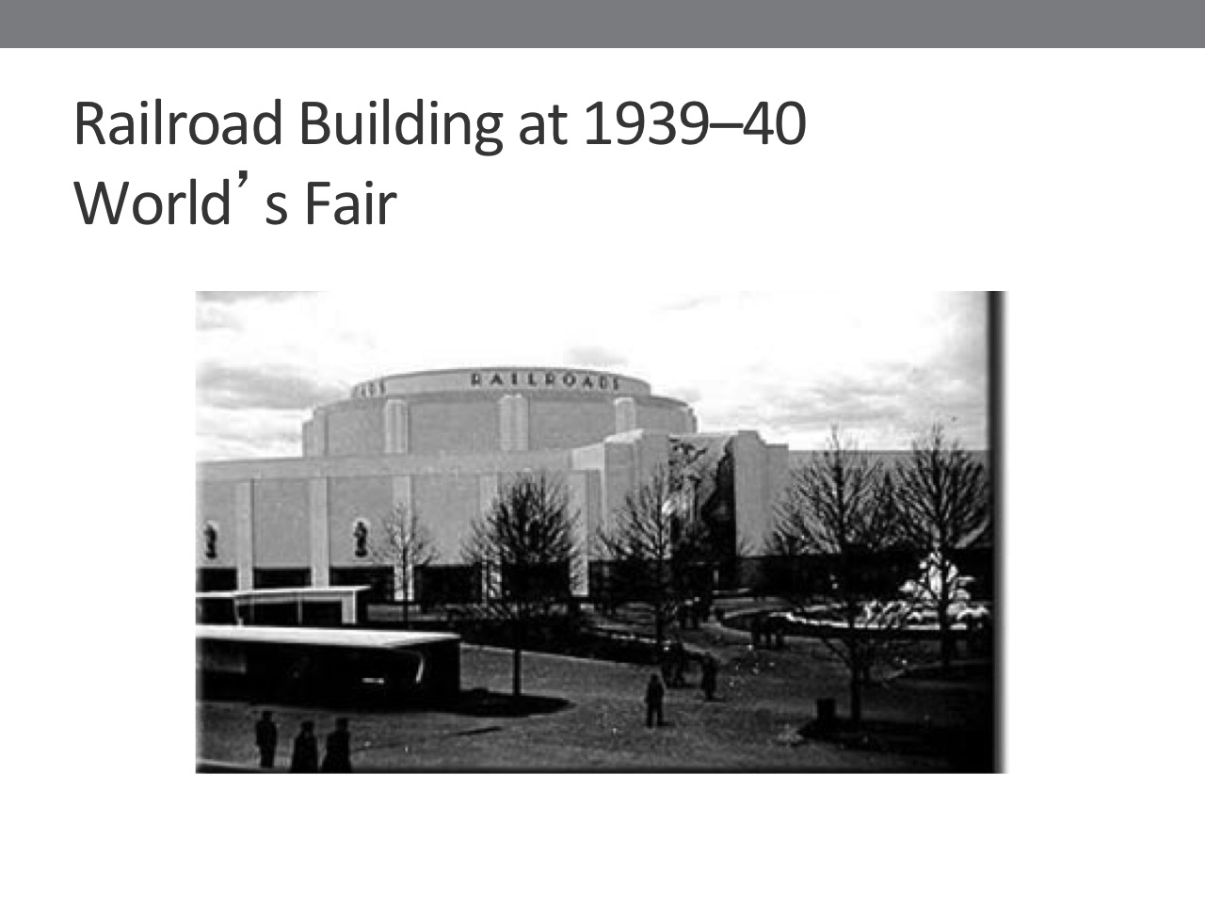
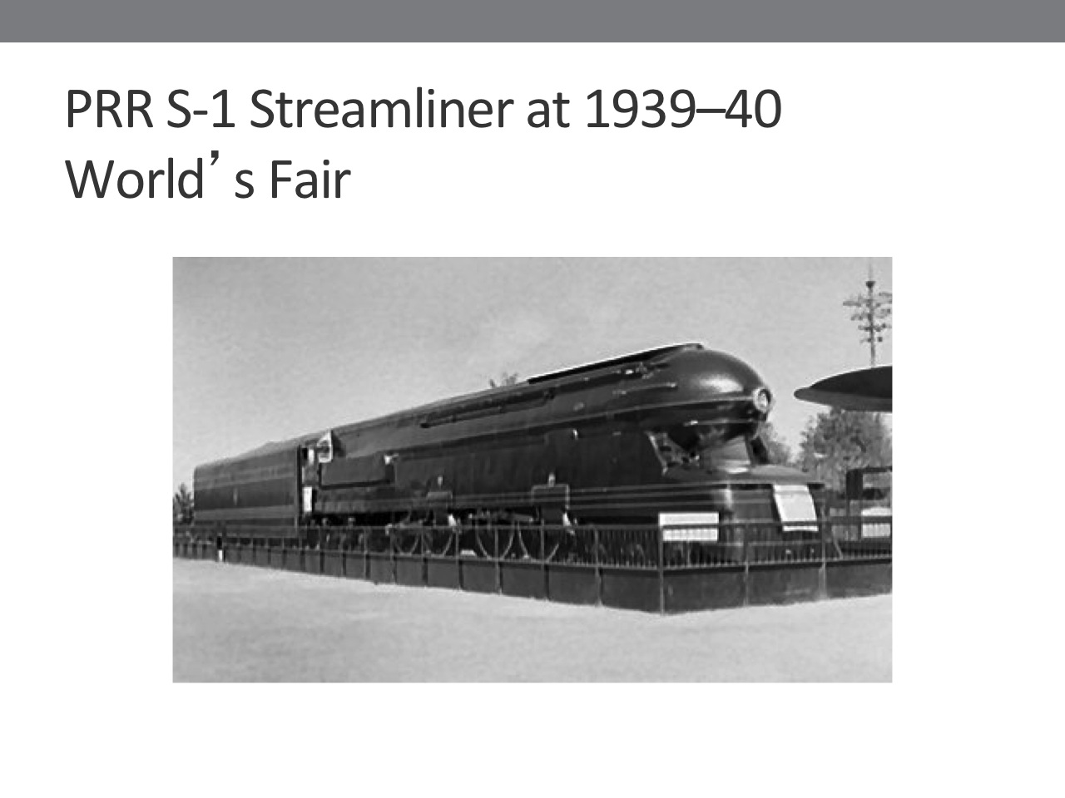
100 years later, in the 1930’s, 40’s, and 50’s, lightweight streamliners, with aerodynamic designs, (SLIDE 21: NEW HAVEN RR “COMET”) increased commercial speeds on the NE, Texas, and California corridors by between 22 and 47%, as shown in the charts I previously displayed. The railroads spent lavishly to promote these trains, and they were often featured in films, in mass media such as Life Magazine; and in prominent displays at the Chicago, New York, and other Worlds’ Fairs held in the 1930’s. (SLIDE 22: RR BLDG AT WORLD’S FAIR)
Slide 22
Slide 23
1. Note the separate building for RR exhibit.
Streamliners became a symbol of modernity, part of a more general glorification of speed, which was absorbed into the national consciousness. (SLIDE 23: STREAMLINER AT WORLD’S FAIR)
1. Note the PRR Streamliner on display at the World’s Fair in New York.
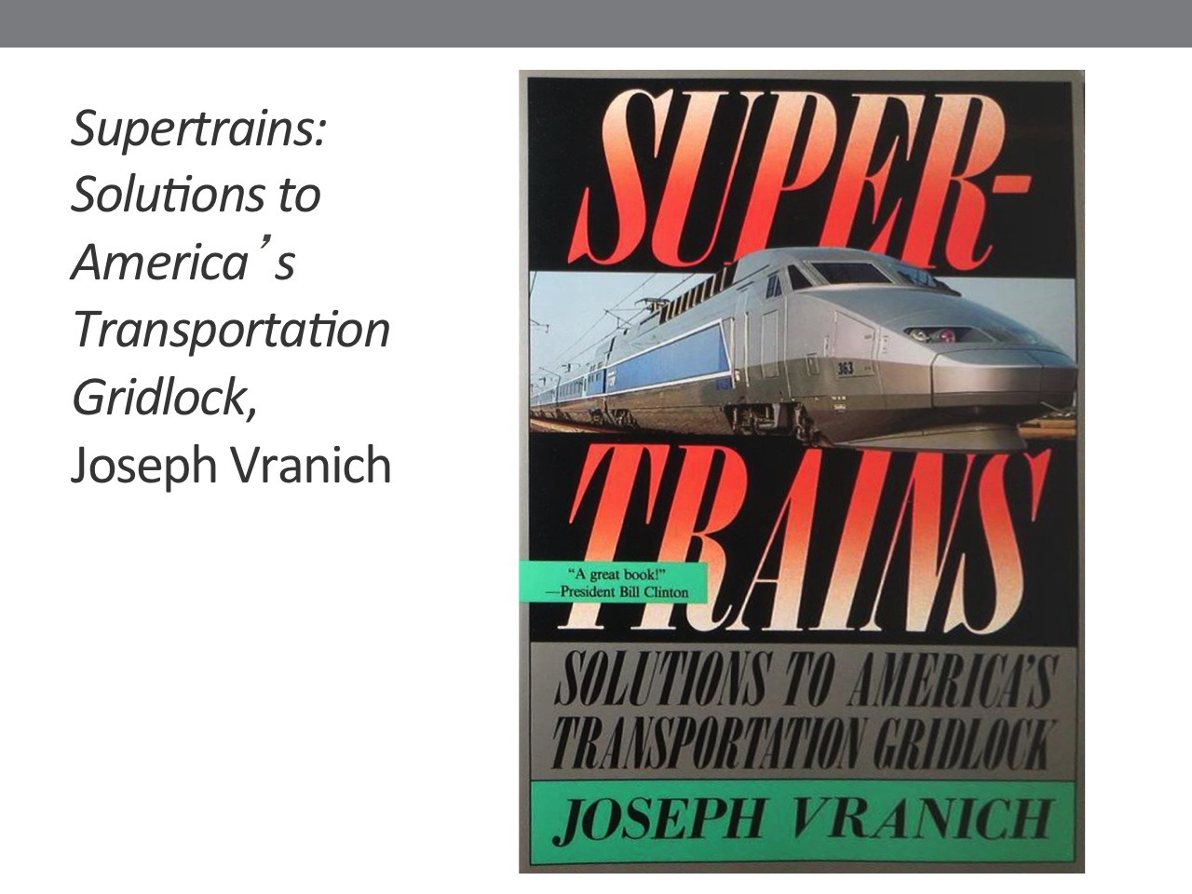

In the 1950’s, high speed streamliners began to lose out in their competition with highway-based transport, and passenger rail began a steep decline in the U.S. Yet, soon thereafter, a new era of high speed trains was ushered in, (SLIDE 24: VRANICH SUPERTRAINS BOOK COVER) when Japan began running its Bullet Train between Tokyo and Osaka, hitting top speeds in excess of 150 mph. The U.S. Congress funded the development of Metroliners, and many European and Asian countries followed, leading to a worldwide revival of high speed railways. These trains were, and continue to this day to be widely characterized in newspapers, on television, in movies, and in advertising, as “supertrains,” “hyper speed,” “ultra fast,” and “very high speed.” High speed trains are part of the national consciousness in the current era, just as they were in the mid-20th century, and in the early-to-mid 19th century. (SLIDE 25: SILVER BULLET CHRISTMAS BEER POSTER )
Slide 24
Slide 25
1. Note that even Coor’s Beer has a high speed train in its advertising.

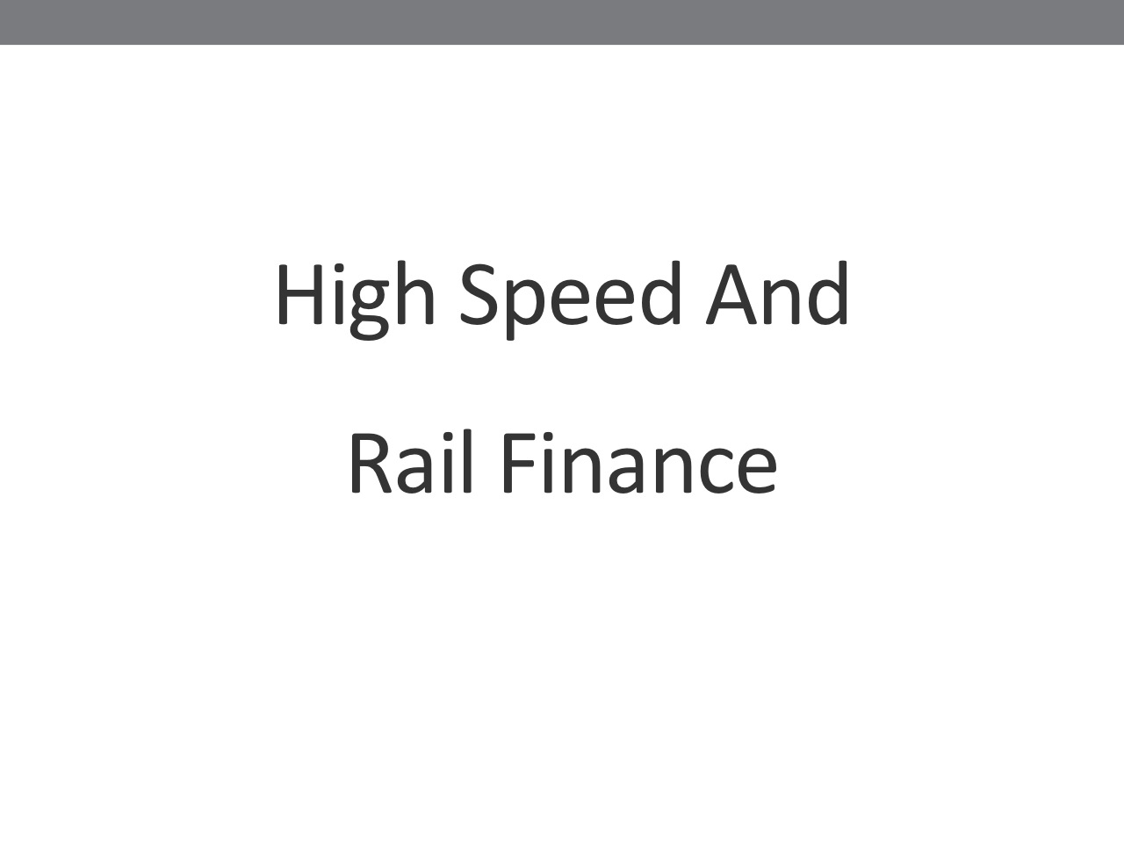
HIGH SPEED AND RAIL FINANCE (SLI DE 26: “HIGH SPEED AND FINANCE”)
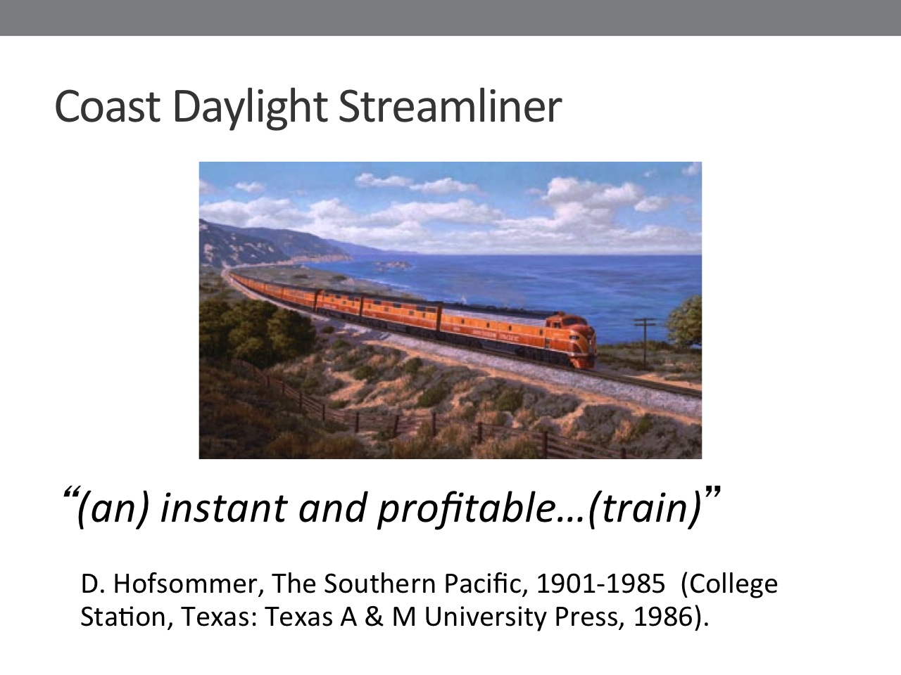
Numerous studies have shown that when train speed increases, it leads directly to an increase in ridership. Thus, at each historic period of high speed, trains were better able to compete with other modes of transport, and were more likely to be profitable. For example, in the 1930’s, when railroads were in serious financial trouble because of competition from the automobile and buses—as well as because of the Great Depresssion—they responded by developing high speed streamliners. (SLIDE 27: COAST DAYLIGHT STREAMLINER)
Slide 26
Slide 26
1. As the slide shows, the Southern Pacific’s Daylight streamliner between SF and LA was “(an) instant and profitable…(train).” The same was true for the PRR’s New York to Washington, D.C. trains, which were part of what the PRR called their “fleet of modernism.” (SLIDE 28: PRR’s FLEET OF MODERNISM, WITH QUOTE JUXTAPOSED) In general, as Middleton and Reutter state: “(b)uilding a margin of time savings over automobiles and buses, the(se) trains attracted standing-room-only crowds and returned solid earning to their owners…(E)very minute saved in transit was likely to generate 1 per cent more traffic (and, thereby, higher earnings)”
Slide 28
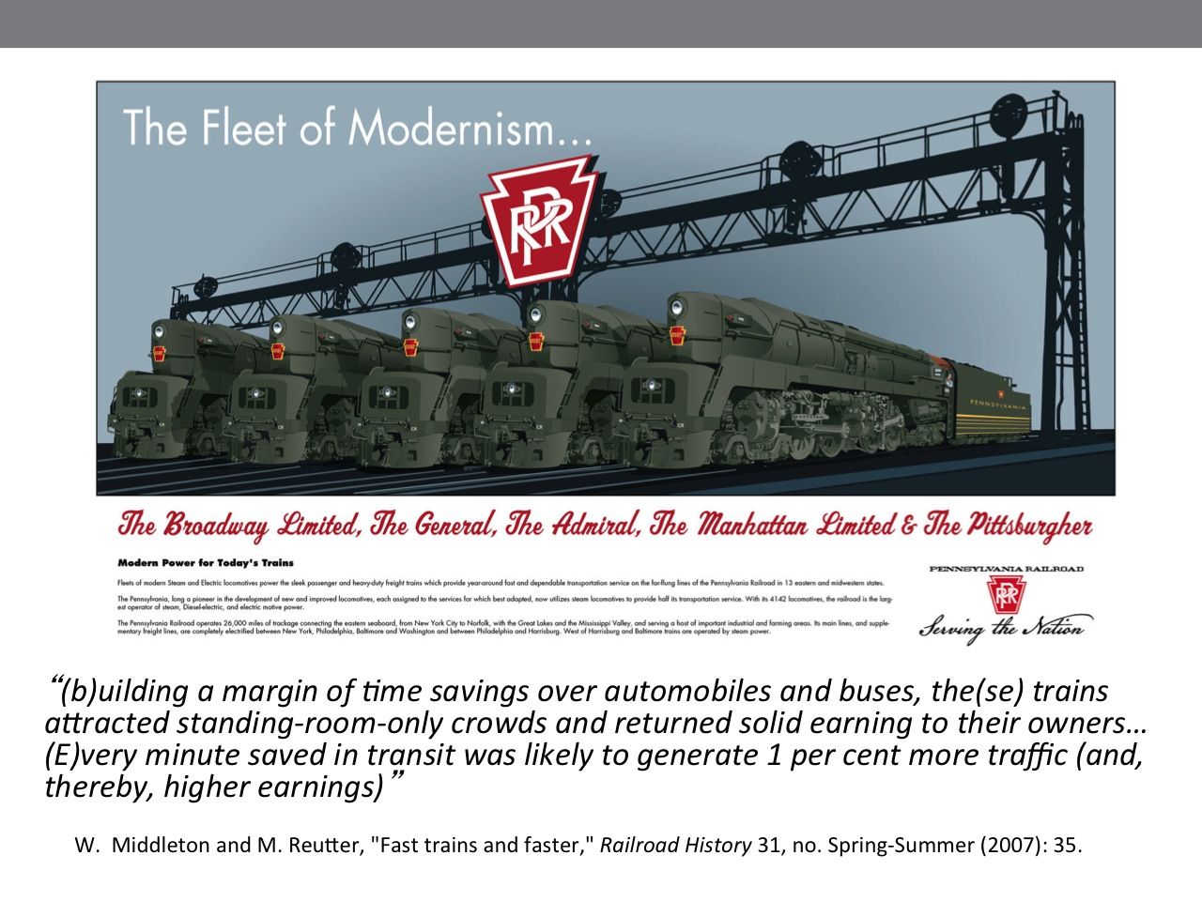
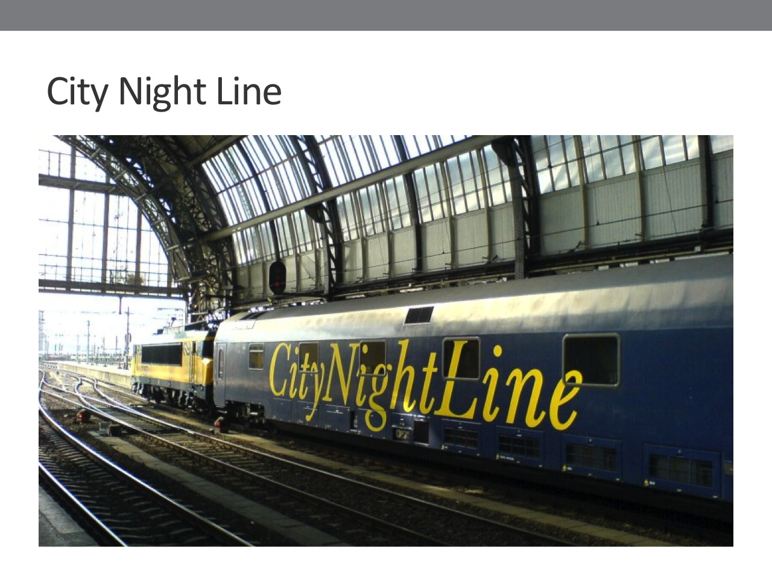
From a dialectical perspective, slowness as well as fastness has potential utility in rail transport. City Night Line, a subsidiary of Deutsche Bahn, (SLIDE 29: CITY NIGHT LINE TRAIN) the German National Railway Company, runs trains at deliberately slow speed, on routes such as Paris-Rome, Amsterdam-Munich, and Berlin-Vienna. Travelers depart one city in the evening, and arrive at their destination in the early morning. In recent years, according to documents I have looked at, some of these routes have been profitable.
Slide 29

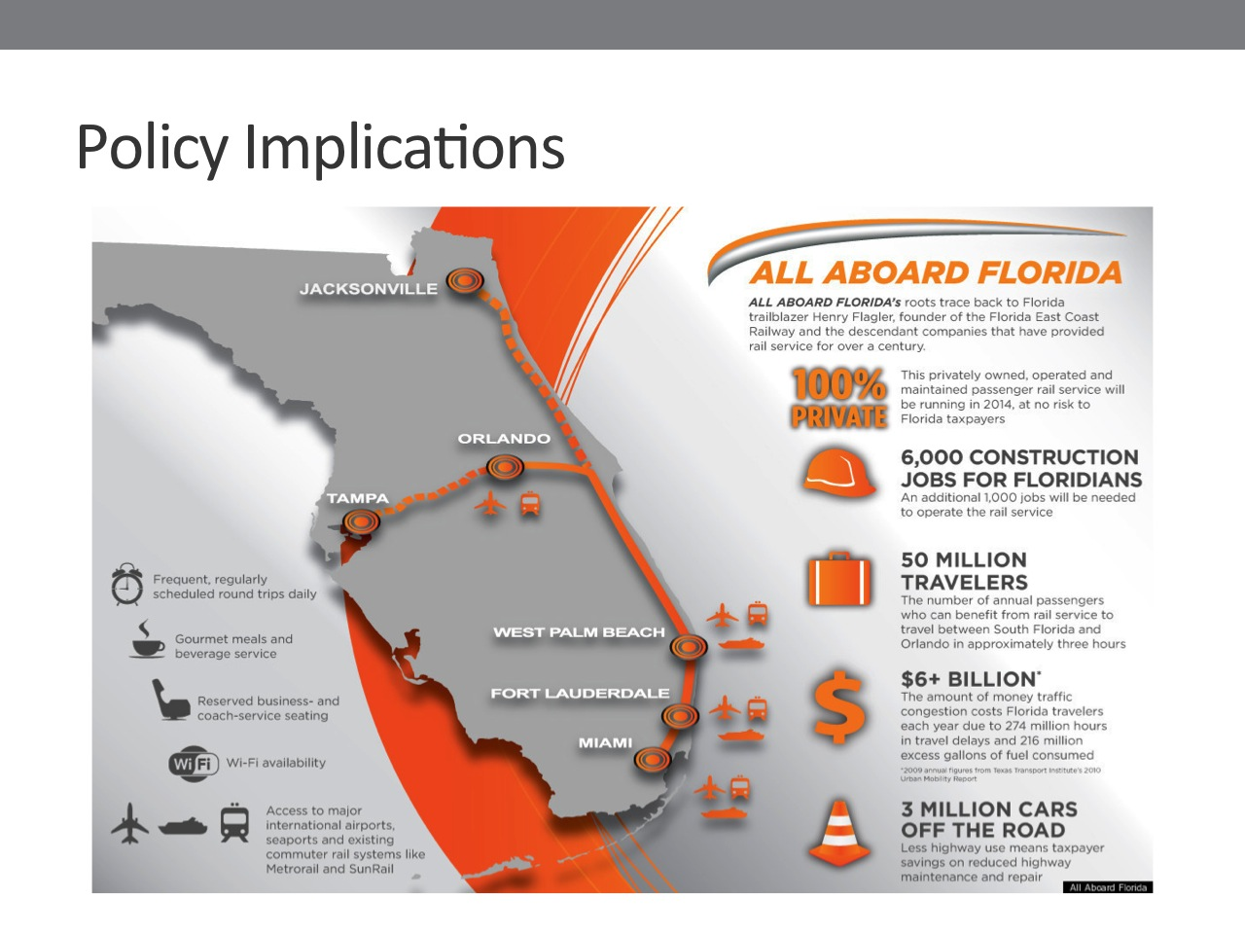
(SLIDE 30: ALL ABOARD FLORIDA) POLICY IMPLICATIONS
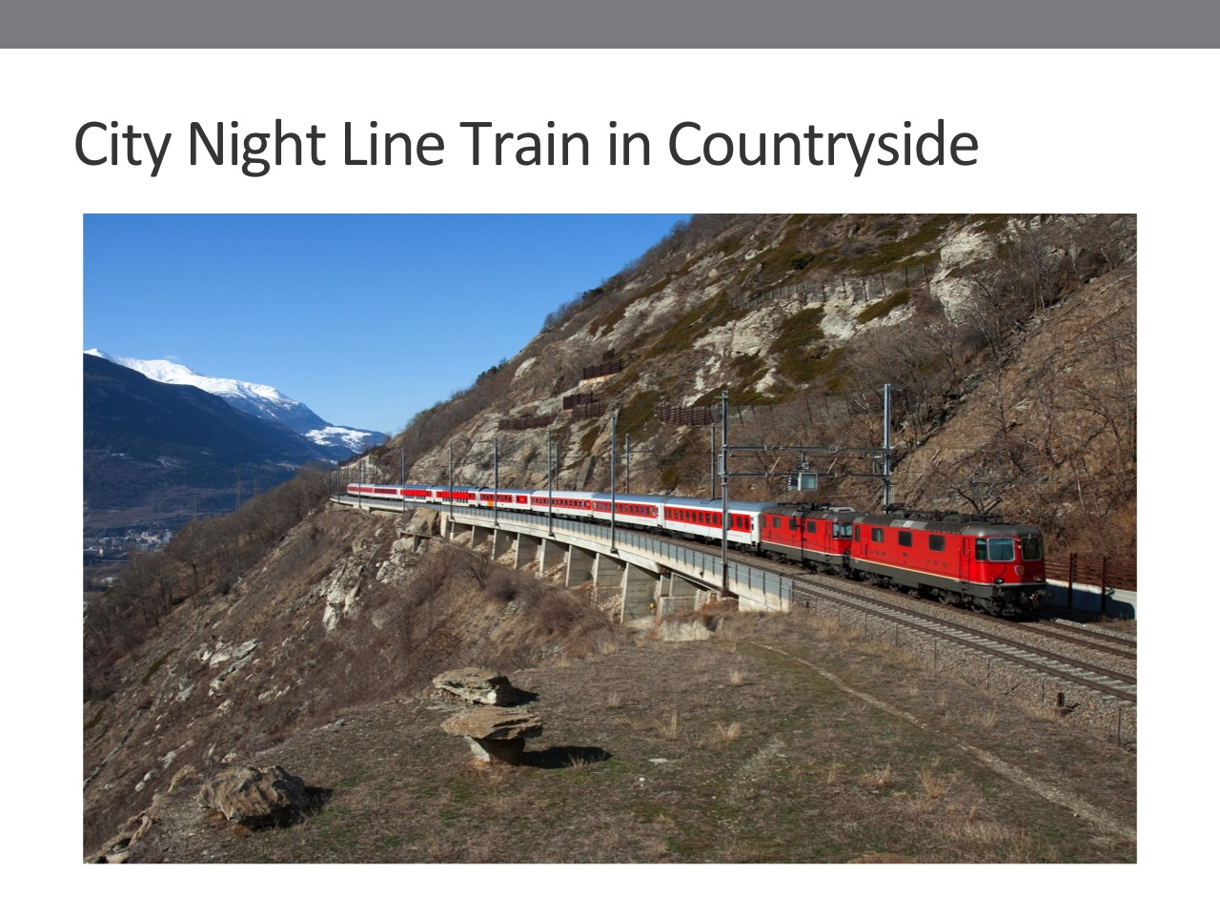
I conclude that passenger trains have profit potential in 2 historical circumstances: first, when they are marketed effectively, and therefore perceived by travelers as high speed, they can both induce new ridership and draw ridership away from other modal choices—assuming the ticket price is competitive with other travel modes; and, second, when slowness serves travelers’ interests, slow trains can also be profitable. In the first instance, with high speed trains, a company called All Aboard Florida is developing a rail line between Tampa, Orlando, and Miami. (Point out cities on slide.) They call their line high speed, even though trains will only operate 125 mph maximum, about the same top speed as streamliners in the 1930’s, 40’s, and 50’s. Using effective marketing—the social construction of high speed—All Aboard Florida believes they can convince enough people to ride their trains so as to generate a profit. Similarly, in the case of slowness, City Night Line in Europe (SLIDE 31: CITY NIGHT LINE IN COUNTRYSIDE) is considering the introduction of medium speed trains that will run long distances, on existing, dedicated, high speed track—for example, between Paris and Madrid—in order to compete with short haul airlines, such as Ryannair. In sum, I am arguing that absolute rate of speed is not the key factor for the future economic and financial viability of passenger rail. Instead, the key factors are, first, the effectiveness of marketing and the social construction of speed; second, resulting subjective perceptions of speed by travelers; and, third, speed, convenience, and cost relative to alternative modal choices. History supports my arguments, and makes me hopeful about the future viability of passenger railways in the U.S. and abroad. (SLIDE 32: TITLE PAGE)
Slide 30
Slide 31
Slide 32

REFERENCES
Hofsommer, D. The Southern Pacific, 1901-1985. College Station, Texas: Texas A & M University Press, 1986.
Marshall, J. Rail: The Records. Enfield, England: Guiness Superlatives, 1985.
Middleton, W. , and M. Reutter. "Fast Trains and Faster." Railroad History 31, no. Spring-Summer (2007): 22-41.
Schivelbusch, W. Railway Journey:The Industrialization of Time and Space in the 19th Century. Berkeley: University of California Press, 1986.

J. Marshall, Rail: the records (Enfield, England: Guiness Superlatives, 1985). 17.
W. Schivelbusch, Railway journey:the industrialization of time and space in the 19th century (Berkeley: University of California Press, 1986). 33-34.
Ibid.
D. Hofsommer, The Southern Pacific, 1901-1985 (College Station, Texas: Texas A & M University Press, 1986).
Personal communication, 2013.
W. Middleton and M. Reutter, "Fast trains and faster," Railroad History 31, no. Spring-Summer (2007): 35.
Real estate development will also contribute greatly to profitability of this line.

